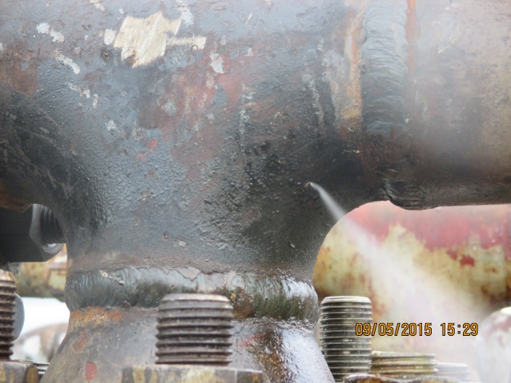 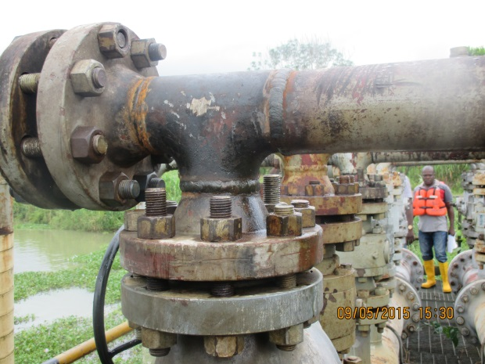 Fig. 1a Pin Hole from Ruptured Manifold Fig.1b @ 6 O’clock Position
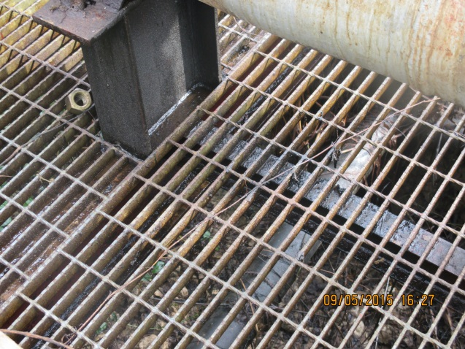 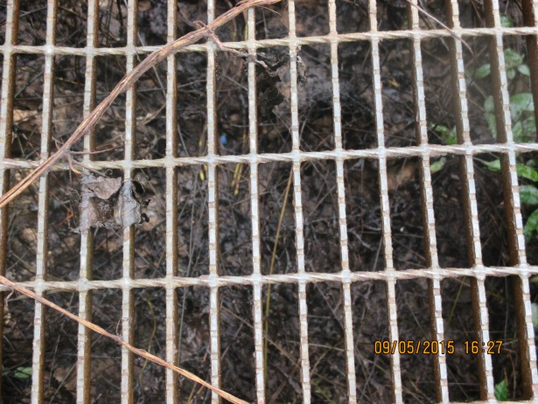 Fig. 2a Facility affected by Gas/Condensate Fig. 2b Grasses Impacted
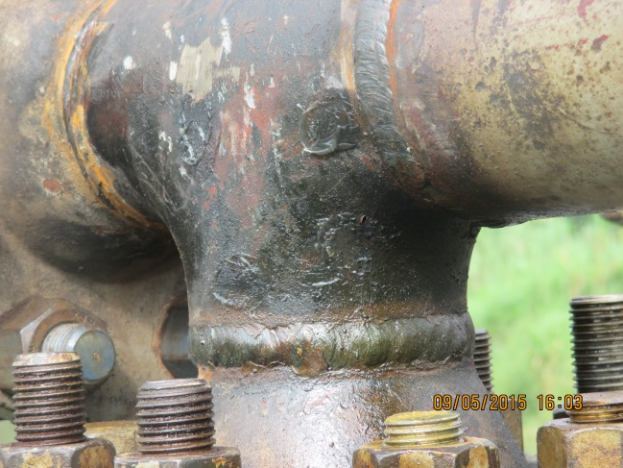
Fig. 3a Flange - Sectional Replacement

